**PIR SENSOR**

A **passive infrared sensor** (PIR sensor) is an electronic sensor that measures infrared (IR) light radiating from objects in its field of view. They are most often used in PIR-based motion detectors. PIR sensors are commonly used in **security alarms and automatic lighting applications**. PIR sensors detect general movement, but do not give information on who or what moved. For that purpose, an active IR sensor is required.

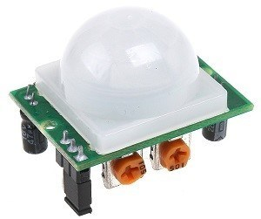

It has two built-in potentiometers to adjust the delay time (the potentiometer at the left) and the sensitivity (the potentiometer at the right).

**PIN CONFIGURATIONS**

GND – connect to ground

OUT – connect to an Arduino digital pin

5V – connect to 5V

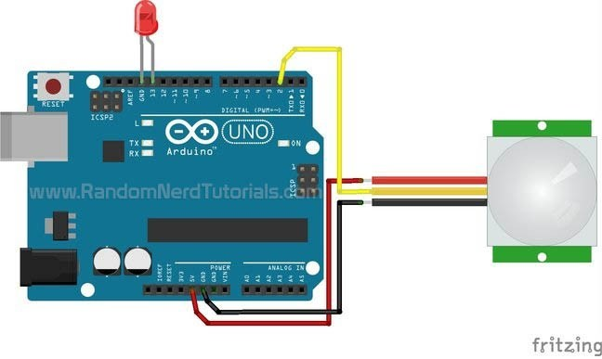

**CODE**

int ledPin = 13; // LED

int pirPin = 2; // PIR Out pin

int pirStat = 0; // PIR status

void setup() {

pinMode(ledPin, OUTPUT);

pinMode(pirPin, INPUT);

Serial.begin(9600);

}

void loop(){

pirStat = digitalRead(pirPin);

if (pirStat == HIGH) { // if motion detected

digitalWrite(ledPin, HIGH); // turn LED ON

Serial.println("Hey I got you!!!");

}

Else{

digitalWrite(ledPin, LOW); // turn LED OFF if we have no motion

}

}

**OUTPUT**

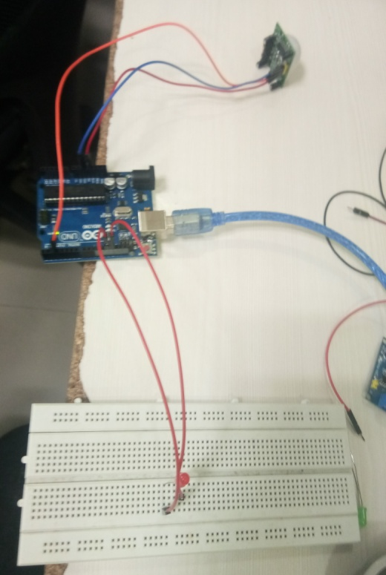 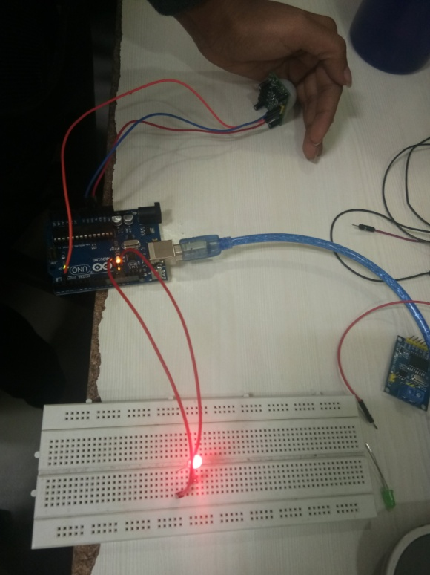

When no motion is detected . when motion is detected, LED turns ON.